PROJECT REPORT

STATIC SMART STUDY PLANNER

(USING PYTHON AND PROLOG

Fundamentals of AI and ML

Submitted by : Saket Singh
Registration No. : 25BCE11055

1. Introduction
Time management is a common challenge for students, especially when handling multiple subjects, deadlines, and varying difficulty levels. Many students either overestimate their capacity or fail to prioritize tasks effectively, leading to stress and incomplete work.
This project presents a Smart Study Planner, which helps students generate an optimized daily study schedule. The system combines Python for user interaction and scheduling with Prolog for logical reasoning and priority assignment. The goal is to create a simple planner that mimics human decision-making when prioritizing tasks.

2. Objective
The main objectives of this project are:
- To design a system that collects and manages study tasks.
- To assign priorities based on deadlines and difficulty using logical rules.
- To generate a feasible daily study schedule within available time.
- To demonstrate integration between Python and Prolog.

3. Problem Statement
Students often struggle to:
- Decide which task to start first.
- Balance difficult and easy subjects.
- Complete work within limited time.
Traditional planners lack intelligence. hey do not adapt based on urgency or complexity. This project solves that by introducing rule based prioritization using Prolog.

4. Technologies Used/ Prerequisite
- Python
  - Handles user input, scheduling, and output display.
  - Uses datetime library for time calculations.
- Prolog (via pyswip)
  - Implements logic rules for determining task priority.
  - Provides reasoning capabilities not easily handled by procedural code.
  - https://www.swi-prolog.org/
- pyswip
  - A bridge between Python and Prolog.
  - Installed using pip install prolog

5. System Design
1) Each task is represented using a Task class with the following attributes:
- name :n Name of the task
- subject : Subject category
- deadline : Submission date
- difficulty: Scale from 1 to 5
- duration : Time required (in hours)
- priority : Computed using Prolog rules

2) Priority is calculated based on:
- Number of days left until the deadline
- Difficulty level of the task
Prolog rules determine whether a task is:
- High priority
- Medium priority
- Low priority

3) Task Schedulingusing greedy Algorithm

4) Time Allocation
Assuming the student starts his work from 16:00 it is defaulted in the source code to start the projects at this time

6. Implementation
This project has 3 moodules:
- Input Module
- Processing Module
- Output module

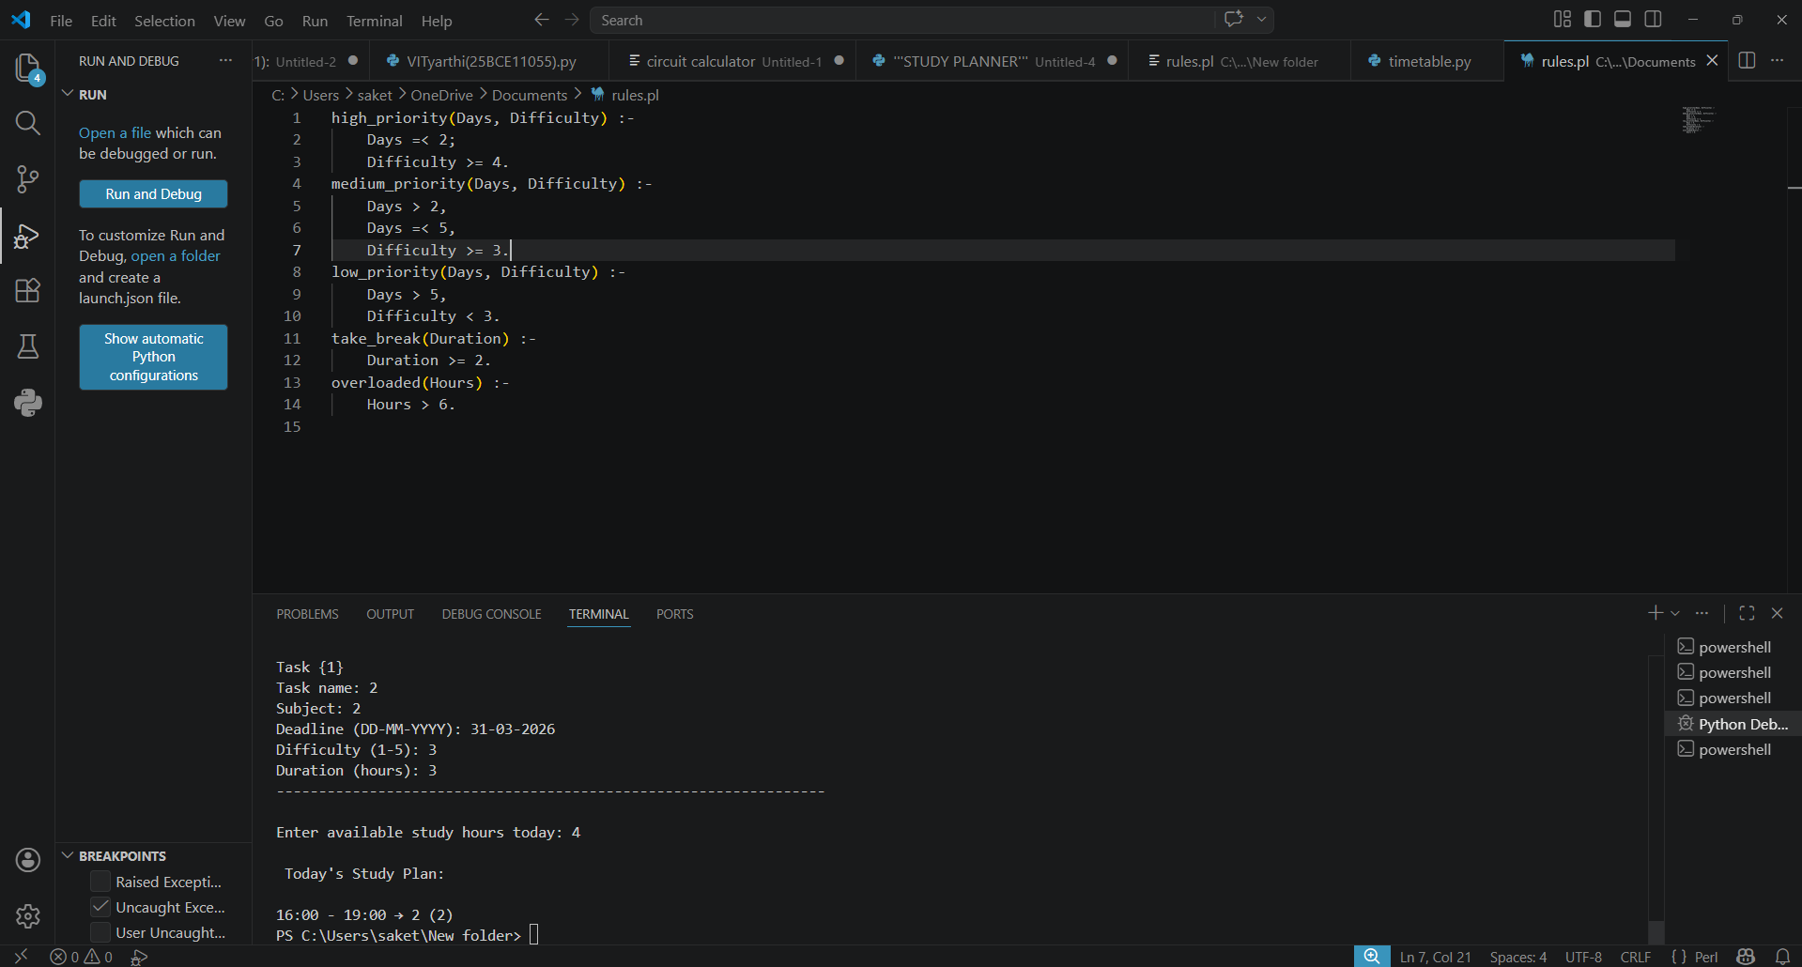

7. Key Features
1. Intelligent prioritization using Prolog
2. Dynamic scheduling based on available hours
3. Task splitting for better time utilization
4. Simple and user-friendly interface
5. Modular design (easy to expand)

8. Limitations And Challenges faced

Fixed start time (4:00 PM)
No graphical interface
Limited to daily planning (no weekly/monthly view)
Requires Prolog installation and configuration
Handling errors while displaying schedules
Managing time calculations correctly
Some issues were resolved by referring to online tutorials and debugging step-by-step

9. Relevancy to course

1. Integration of prolog with python
2. Using classes and appending them, previously taught in python course
3. Algorithm for scheduling task

10. Future Enhancements

Add GUI
Extend to weekly/monthly planner
Include break scheduling
Add learning based prioritization (FOR CLASSIFYING DIFFICULTY OF TASKS)
Sync with calendar apps

11. Conclusion
The Smart Study Planner successfully demonstrates how logic programming (Prolog) can enhance traditional scheduling systems. By combining Python’s flexibility with Prolog’s reasoning capabilities, the project provides a more intelligent way to manage study time.

